Foundation of BackEnd
V1

🔁 Request-Response:
Definition
A communication model where:
- The client sends a request (some data, or a command)
- The server processes it and sends a response back
This model is synchronous and forms the basis for many protocols (like HTTP, DNS, SQL, RPC).
🧱 Anatomy of Request-Response

1. Client Sends a Request
- Request includes:
  - Method (GET, POST, etc.)
  - Headers
  - Path/URL
  - Body (data, like JSON/image)

2. Server Receives and Parses
- The server reads a stream of bytes and must:
  - Identify the boundaries (start & end) of the request
  - Parse headers and metadata
  - Extract and deserialize the body (from JSON/XML/protobuf/etc.)

3. Server Processes the Request
- This is the business logic:
  - Route the request
  - Execute DB queries
  - Perform computations
  - Authenticate user, etc.

4. Server Sends the Response
- Structured similarly:
  - Status code (200 OK, 404 Not Found)
  - Headers (e.g., Content-Type)
  - Body (JSON, HTML, etc.)
- Must also mark boundaries clearly for the client

5. Client Parses and Uses the Response
- Deserialize the body (e.g., JSON.parse)
- Display, store, or use the response

🧪 Parsing & Serialization
Stage | Description
Parsing | Understanding where the request/response begins and ends
Deserialization | Converting raw payload (e.g., JSON, XML) into an object the language understands
Serialization | Opposite: Converting an object to a format suitable for transmission
- JSON is human-readable but slower.
- Protocol Buffers (protobuf) are fast and compact (good for performance).
- XML is verbose and expensive to parse (hence not favored now).

🗃️ Use Cases of Request-Response
- HTTP APIs (REST, GraphQL)
- DNS queries (UDP-based but still request-response)
- SQL Queries (send a query, get results)
- RPC (call a method on another server)
- File Uploads (especially with chunked uploads)

🧩 Limitations
- Client must initiate → not ideal for real-time updates (e.g., chat, notifications)
- Can lead to polling overhead
- Can be inefficient for large file uploads or high-frequency calls

⚙️ Chunked Uploads (Example)
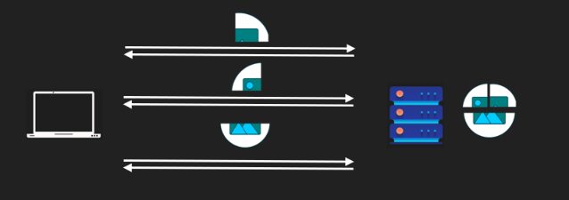
- Break large files into parts (chunks)
- Each chunk is sent as a separate request
- Server reconstructs the full file
- Benefits:
  - Resumable uploads
  - Lower memory usage
  - Better error recovery

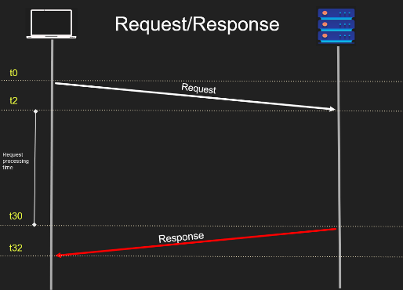
• T-2 to T0: Client serializes and sends the request (e.g., converts a JavaScript object to JSON).
• T0 to T2: Network transfer time (TCP segments, IP packets, potential reordering).
• T2 to T3: Server parses the request to understand its structure.
• T3 to T10: Server processes the request (e.g., database query).
• T30 to T31: Server serializes and sends the response.
• T31 to T32: Network transfer time for the response.
• T32 to T33: Client parses and consumes the response.

Think of the acronym SPPPR (Serialize, Parse, Process, Parse, Respond) to remember the flow:
- Serialize (client prepares request).
- Parse (server reads request).
- Process (server executes request).
- Parse (client reads response).
- Respond (server sends response).

V2

🚀 Push Pattern: Core Idea
The server pushes updates to the client without the client needing to request them every time.

✅ Perfect Use Cases:
- Real-time notifications (e.g., "user X just liked your tweet")
- Chat apps
- Live game scores
- Collaborative editing (e.g., Google Docs updates)

🔄 How It Works
- Connection is established (usually long-lived).
- The server holds this connection open.
- When something important happens (e.g., video uploaded), the server pushes data to all connected clients.
Think of it like the server whispering directly into the client's ear without being asked first.

⚙️ Examples of Protocols & Tools
- WebSockets – Bidirectional protocol used heavily in chat apps and multiplayer games.
- Server-Sent Events (SSE) – Unidirectional (server → client), simpler for streaming updates.
- gRPC (server-streaming) – Client makes one request, then gets a stream of responses.
- RabbitMQ – Queues messages and pushes them to consumers.
- Kafka – Chooses a pull model (for reasons we’ll cover).

📈 Push Pros
- ⚡ Real-time delivery: Instant updates without polling.
- 💬 Natural for events: Makes sense for chat, notifications, feeds.
- 📉 Reduced latency: No need to wait for periodic polling.

⚠️ Push Cons
- ❌ Client must stay online: Otherwise, it misses the data.
- 🔥 Resource-heavy on server: Imagine pushing updates to 100M YouTube subscribers.
- 📉 Overload risk: If the server sends too much, slow clients may crash or fall behind.
- 🧠 Server lacks client state awareness: Can't always tell if client is struggling.
That's why Kafka uses a pull model — consumers control when they fetch data, which avoids overloading them.

🧠 Mental Model (Push vs Pull)
- Push = Server speaks first. Like a teacher broadcasting announcements.
- Pull = Client asks first. Like a student raising a hand to ask a question.
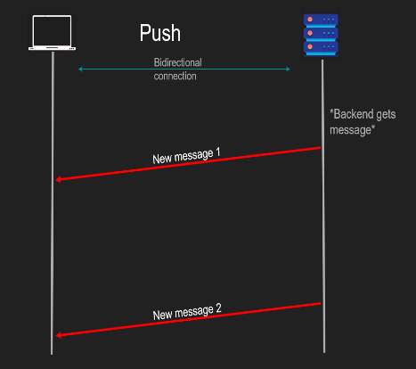

🧪 Bonus Visualization
text
CopyEdit
[Server] →→→ Push data →
← Connection ←
[Client]
The key is the connection. Push requires it to be live -like a pipe you can instantly shoot data through.

✅ Summary
Feature | Request-Response | Push (WebSocket/SSE)
Initiated by | Client | Server (once connected)
Real-time | ❌ | ✅
Works offline | ✅ | ❌
Good for events | ❌ | ✅
Risk of overload | ❌ | ✅
Protocols | HTTP | WebSocket, SSE, gRPC

🔁 Short Polling (a.k.a. Polling)

🔍 What is it?
A design pattern where:
- The client sends repeated requests at short intervals to ask:
"Is my task done yet?"
- The server replies:
  - No, not yet.
  - Or Yes, here’s the result.

🧠 When is it used?
- When backend tasks take time (e.g., video processing, file uploads).
- When real-time feedback is not critical, but eventual result is.
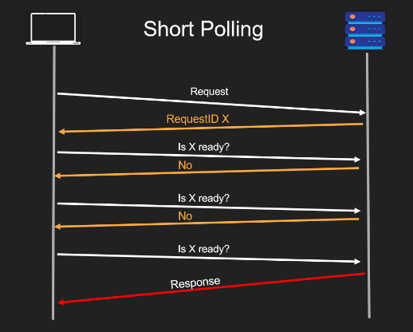

⚙️ How it Works:
- Client sends a request to initiate a task (e.g., video upload).
- Server replies immediately with a handle (job_id, task_id, etc.).
- Client uses this handle to repeatedly ask:
  - “Is the task done yet?”
- Server checks and replies:
  - If not done → return "no"
  - If done → return the result

✅ Pros:
- Simple to implement.
- Works well for asynchronous long-running tasks.
- Client can disconnect and check back later.
- Backend and client are decoupled — less blocking.

❌ Cons:
- Too chatty (frequent network requests).
- Wastes network bandwidth and backend resources.
- Doesn’t scale well when many users are polling frequently.
- High chance of polling for no result (most polls return “not yet”).

📌 Real-World Example:
Imagine uploading a video to YouTube:
- You upload, and get back an upload_id.
- YouTube processes it asynchronously.
- The frontend polls:
“Is processing complete for upload_id XYZ?”
- When it is, the response returns success and processed video info.

🧪 Push vs. Polling Comparison:
Feature | Push | Polling
Real-time | ✅ Yes | 🚫 No (depends on interval)
Network load | ❌ High (server-driven) | ❌ High (client-driven)
Offline support | 🚫 No (client must be online) | ✅ Yes (can resume later)
Scalability | ⚠️ Difficult (stateful) | ⚠️ Difficult (chatty)
Use Case | Chat apps, live updates | Long-running jobs, uploads

🟢 LONG POLLING — "Don’t Talk Until You Have News"
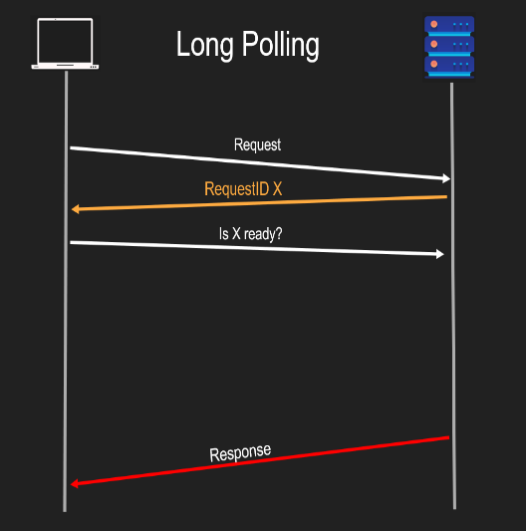
🕓 Pattern:
- Client sends request.
- Server does NOT reply immediately.
- Server waits until there’s new data or status is done, then responds.
- If no data comes before timeout, server responds with "nothing yet."
📦 Use Case:
- Event-driven systems.
- Notification services.
- Message queues (like Kafka consumers).
✅ Pros:
- Less chatty: One request stays open.
- Efficient: No repeated false checks.
- Back-end friendly: Saves bandwidth and CPU.
- Client controls flow: Helps slow clients avoid overload.
❌ Cons:
- Not 100% real-time: If the client gets a message, disconnects, and more data arrives, it may miss them until it reconnects.
- Complex timeout logic: Server/client both need timeout strategies.
- May require connection pooling: Open sockets are limited resources.

🔄 Visual Metaphor
Pattern | Visual | Analogy
Short Polling | ⏰⏰⏰⏰⏰ | “Are we there yet?” every few minutes
Long Polling | 🛎️ (waits silently) | “Tell me when dinner is ready”

🔑 Remember This:
- Short Polling: Frequent pulls regardless of whether there's anything new.
- Long Polling: Persistent pull, server responds only when something new is available.
- Both are still technically based on request-response, just structured differently.

* Quiz:
1. What happens after a client sends a request in the request-response pattern?
A) The client continues without waiting
B) The server sends a response, and the connection stays open
C) The server sends a response and the connection usually closes
D) The server pushes data when it is ready
2. Which of the following best describes the request-response model?
A) Asynchronous communication initiated by the server
B) One-time synchronous communication initiated by the client
C) Real-time, persistent communication
D) One-way communication only
3. In the push model, who initiates the data transfer?
A) Client
B) Server
C) Database
D) Message queue
4. What is a potential problem with the push model?
A) It is too slow for real-time systems
B) It uses long polling underneath
C) The client may be overwhelmed with unsolicited data
D) The server waits too long to respond
5. What is typical behavior in basic polling?
A) The server repeatedly checks for updates
B) The client sends repeated requests to check for updates
C) The server sends updates without a request
D) The client waits silently for changes
6. Why is frequent polling considered inefficient?
A) It delays server response
B) It increases real-time speed
C) It consumes unnecessary bandwidth and CPU
D) It requires a database
7. What does the server do in long polling when data is not ready?
A) Responds with "not ready" immediately
B) Pushes dummy data
C) Waits without responding until data is ready
D) Terminates the connection
8. What is a key advantage of long polling over basic polling?
A) It provides persistent connections
B) It reduces client-side complexity
C) It avoids flooding the server with frequent requests
D) It is faster than WebSockets

🌟 Server-Sent Events (SSE) — Easy Guide

🧠 What are Server-Sent Events (SSE)?
- A client opens a regular HTTP connection.
- Server keeps the connection open and streams messages to the client continuously.
- It's one request → many responses (event stream).
- The server never closes the HTTP response — unless necessary.
It's like starting a conversation — and keeping it open forever to whisper messages whenever needed.

⚙️ How SSE Works (Simple Flow)
plaintext
CopyEdit
Client → sends 1 HTTP GET request → Server
Server → streams many "mini" responses (events) → Client
Client → parses incoming events automatically
- No need to send multiple requests like polling.
- Uses text/event-stream Content-Type.
- Each message is a small formatted text block (an "event").

📦 Why SSE is Brilliant
- Simple: Works over normal HTTP/1.1 — no complex WebSocket upgrade needed.
- Real-Time: Push events to clients without client asking.
- Built-in Support: Browsers have EventSource API (new EventSource(url)).
- Streaming: Like WebSockets but simpler for one-way (server → client).

🔥 Pros of SSE
Advantage | Explanation
✅ Real-Time Updates | Server pushes events immediately
✅ Easy to Implement | Native browser support with EventSource
✅ Built on HTTP | Works with proxies, firewalls easily
✅ Light Resource Usage | Only server → client stream, no full TCP handshake for every event

⚠️ Cons of SSE
Limitation | Why it Matters
❌ Client must be Online | If client disconnects, events are lost unless retried
❌ Limited Browser Connections | Chrome limits 6 concurrent connections to one domain (HTTP/1.1)
❌ One-Way Only | Server → Client (cannot send Client → Server messages directly)
❌ Vulnerable to Overload | If server floods events, weak clients may crash

🧪 Real-World Use Cases
- Live sports scores.
- Stock market updates.
- Notifications (email received, someone messaged you).
- Dashboard live statistics (CPU usage, memory, etc.).

🌎 SSE vs WebSocket vs Polling
Feature | SSE | WebSocket | Polling
Direction | Server → Client | Client ↔ Server (2-way) | Client → Server
Complexity | Very low | Medium-High | Low
Browser Support | High | High | High
Real-time Updates | Good | Best | Poor
Setup | Just HTTP GET | HTTP Upgrade (TCP Upgrade) | Repeated HTTP requests

⚠️ Browser Connection Limitation (Important!)
Problem | Details
Chrome/Firefox connection limit | Max 6 TCP connections to the same domain
Why it's bad? | If SSE uses 1–2 connections permanently, fewer left for other assets (images, CSS, JS)
Solution (advanced) | Use HTTP/2 or gRPC streams for multiplexing

🧠 Core Idea: Publish-Subscribe Pattern (Pub/Sub)
- Definition: A publisher sends messages to a broker/topic, and subscribers receive those messages. They don’t talk to each other directly.
- Main Benefit: Loose coupling – services don’t need to know about each other.

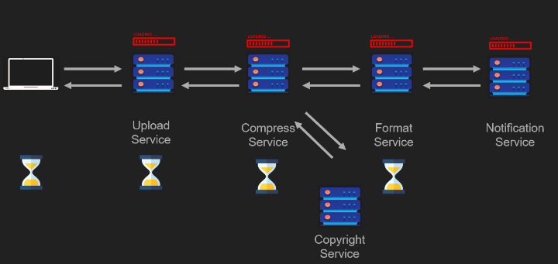
🎯 Why Pub/Sub? Solving Request-Response Bottlenecks
Imagine YouTube:
- A client uploads a video.
- That video must be:
  - Compressed
  - Transcoded into various formats (480p, 720p, 1080p, 4K)
  - Scanned for copyright
  - Notify users once ready

❌ Request-Response Approach:
- Everything happens sequentially.
- The client waits until all services are done.
- If any service fails, the whole chain breaks.
- Very high coupling.

✅ Pub/Sub Approach:
- Client uploads → Upload service publishes the video to a "raw uploads" topic.
- Compressor service subscribes to that topic → compresses it → publishes to "compressed videos" topic.
- Format service subscribes to that → encodes in 480p, 720p, 1080p, 4K.
- Notification and copyright services can listen to specific topics and act accordingly.

🔁 Architecture Flow (YouTube Example)
plaintext
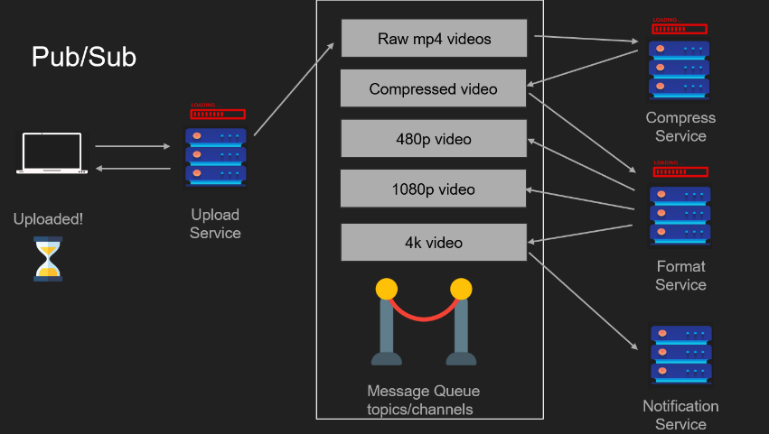
CopyEdit
Client
↓
Upload Service (Publisher)
↓ Publishes to
[Topic: Raw Uploads] → (Broker/Queue)

Compressed Service (Subscriber + Publisher)
↓ Publishes to
[Topic: Compressed Videos]

Format Service (Subscriber + Publisher)
↓ Publishes to
[Topics: 480p, 720p, 1080p, 4K]

Notification / Copyright (Subscribers)
Each step is decoupled, scalable, and can be independently deployed.

✅ Pros of Pub/Sub
- 🔁 Multiple consumers can react to a single event.
- 🔗 Low coupling – services don't depend on one another.
- 🧱 Scales well for microservices.
- 🕓 Consumers can consume when ready (asynchronously).
- 🔌 Better for real-world distributed systems.

❌ Cons of Pub/Sub
- 🧩 Complexity – adds more moving parts (brokers, topics, partitions).
- 🛑 Message delivery problems:
  - At least once (duplicate messages)
  - At most once (missed messages)
  - Exactly once (very hard to guarantee)
- 🌐 Network congestion (especially with polling).
- 🕵️‍♂️ Debugging issues is harder due to async nature.

📦 Real-World Tools
- Kafka: Pull-based, durable, partitions for scalability.
- RabbitMQ: Push-based, supports various queue types (fanout, topic, etc.).
- Redis Streams, Google Pub/Sub, Amazon SNS/SQS – other options.

🎯 Summary
- Pub/Sub solves the scaling and decoupling problem of traditional request-response models.
- Ideal for asynchronous workflows, background tasks, and event-driven systems.
- However, it introduces new operational and architectural challenges.
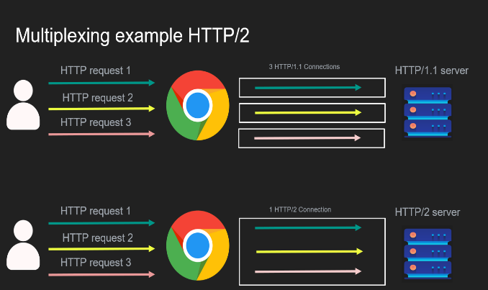
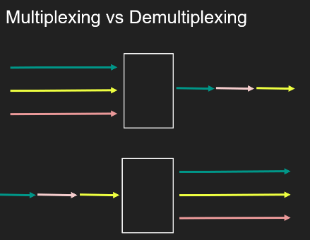

🔁 Multiplexing (Muxing)
Definition: Sending multiple signals (e.g., requests, streams) over a single physical connection.
- Example:
  - In HTTP/2, multiple client requests (streams) are sent over a single TCP connection.
  - Browsers (like Chrome) multiplex multiple HTTP requests into one TCP connection.
- Analogy: Think of several people (requests) sharing one bus (TCP connection) to get to the se
- Benefits:
  - Fewer open connections.
  - Better use of available TCP resources (avoiding port exhaustion).
- Trade-offs:
  - Server needs to parse and handle streams from one connection—CPU-intensive.
  - Head-of-line blocking can occur in protocols like HTTP/2 over TCP.

🔄 Demultiplexing (Demuxing)
Definition: Splitting a single connection’s data into multiple logical streams or sending data to different destinations.
- Example:
  - A proxy server receives a multiplexed HTTP/2 connection and demultiplexes it to send each request to a separate backend server.
- Benefit:
  - Each request can be handled independently, with separate flow/congestion control per connection.

🌐 HTTP Protocols and Multiplexing
- HTTP/1.1:
  - Browser opens multiple TCP connections (usually 6 per domain).
  - No real multiplexing—requests are pipelined or sequential in each connection.
- HTTP/2:
  - Single TCP connection with multiple streams.
  - True multiplexing—client sends multiple parallel requests through one TCP pipe.
  - More efficient but burdens backend to manage stream parsing.

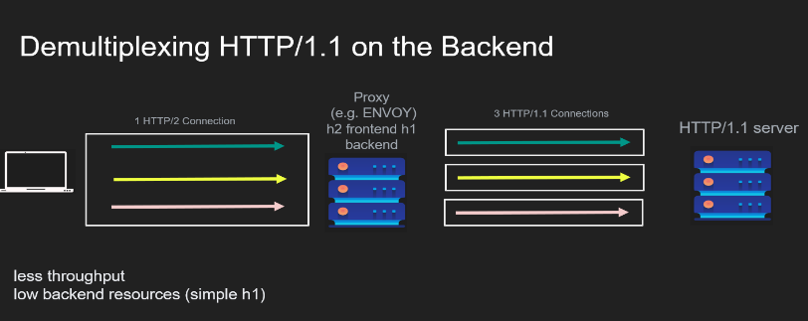
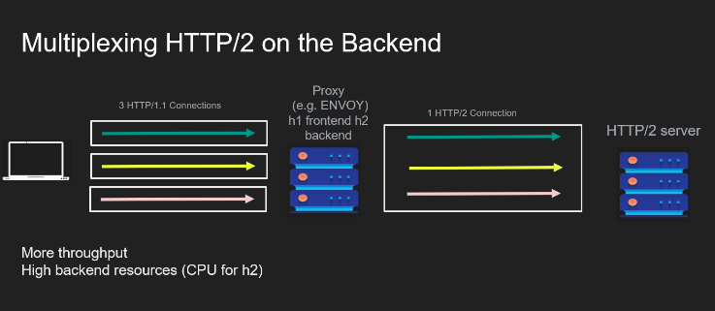
🔁 Reverse Proxy Multiplexing/Demuxing

- Reverse proxy like Nginx or Envoy may:
  - Receive HTTP/1.1 from clients (multiple connections).
  - Open 1 HTTP/2 connection to backend.
  - Multiplex all incoming requests into this one connection.
- Or the opposite:
  - Receive HTTP/2 from client (1 connection with many streams).
  - Demultiplex and send each request over separate HTTP/1.1 connections to backend.

🏊‍♂️ Connection Pooling (e.g., in databases)
- Definition: Maintain a set (pool) of open connections to reuse across requests.
- Use Case:
  - Backend server handles multiple HTTP requests.
  - For each, it uses an available database connection from the pool.
  - If all connections are busy, new requests must wait (blocked).
- Multiplexing in disguise:
The pool acts like a muxer, routing incoming SQL requests to available DB connections.
- Limitations:
  - Some ORMs (like Django’s) open one connection per thread—restrictive.
  - Sending multiple SQL queries on a single connection is hard, because:
    - PostgreSQL responds sequentially.
    - No built-in way to match responses to queries unless pipelining or tagging is used.

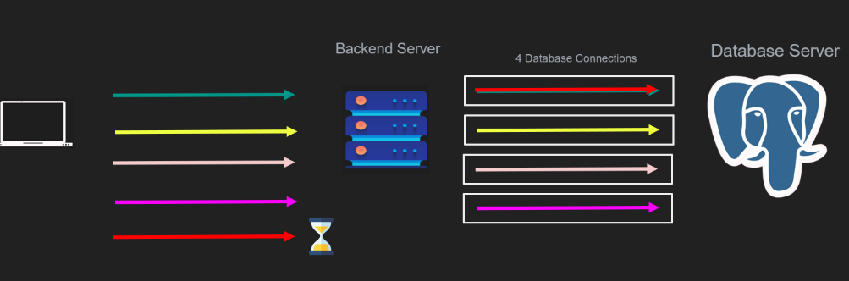

⚠️ Key Limitations
- HTTP/1.1 Limit: Browsers allow only ~6 concurrent connections per origin.
- Multiplexing in HTTP/2: Can cause head-of-line blocking (slowest stream blocks others).
- Connection Pool Saturation: All connections busy = new requests must wait or fail.

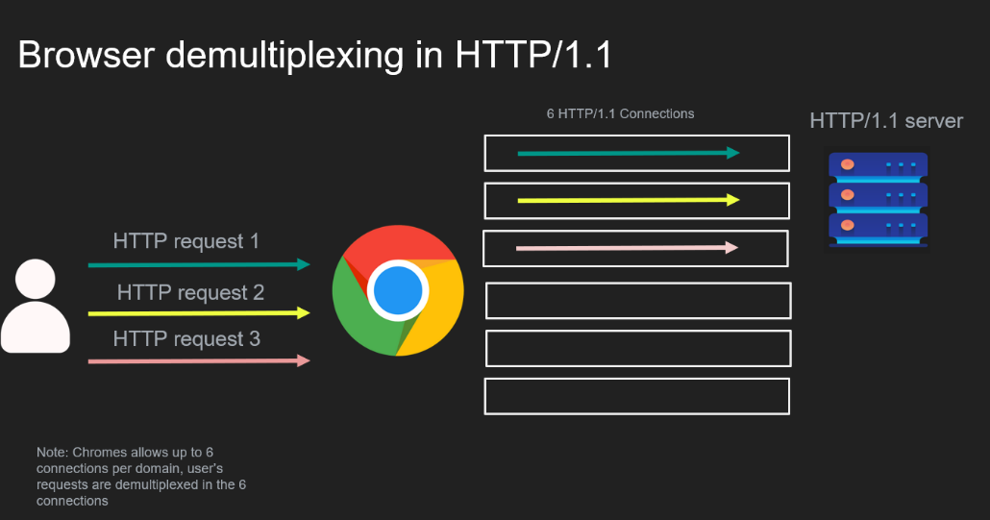

⚖️ Core Concept: Stateless vs Stateful
- Stateless:
The server does not store any information about the client between requests.
The client must send all required information with each request.
If the server crashes and restarts, it can still serve requests correctly.
- Stateful:
The server stores data (state) about the client session in memory or disk.
The app depends on that stored state to function properly.
If the state is lost (e.g., server crash), the app may break or force the client to restart their workflow.

🔑 Core Philosophy:
Forget the textbook definitions. Instead, ask this question:
"Does the system rely on some in-memory or stored state to function correctly?"
If yes, it's stateful.
If no, it's stateless (or at least the part you're talking about is).

🧠 Understanding Through Examples

✅ Stateless Backend (Ideal Case):
- Stores session/user data in external systems (e.g., databases).
- The backend itself can be restarted or scaled up/down without losing context.
- Example:
  - User logs in → server stores session ID in database → user makes another request → server checks session from database, not memory.

❌ Stateful Backend (Problematic at Scale):
- Stores session (like S1) in memory.
- If server crashes, session is lost, and user must log in again.
- Load balancing is tricky: one server may have the session, the other may not.
- This leads to sticky sessions (client requests always routed to same server).

🔄 Stateless Systems Still Store State (Just Not Locally!)
"Your backend can be stateless, even if the system as a whole is stateful."
- Even a stateless backend can store logs, sessions, etc. somewhere else (like DB, Redis).
- But the backend does not rely on in-memory state to work correctly.
- You can scale it freely because all state is externally managed.

🔁 Real-Life Example:
Session Auth in Login Systems
- Stateful: Session stored in memory. If the backend restarts, session is lost, and user is logged out.
- Stateless: Session or token stored in DB. Backend can be restarted, another instance reads from DB — all works smoothly.

📡 Stateful vs Stateless Protocols

TCP (Stateful):
- Maintains connection state (sequence numbers, ACKs, windows).
- If state is lost (connection resets), communication is broken.

UDP (Stateless):
- No connections, no saved state.
- Each packet stands alone.
- Example: DNS (over UDP) uses a query ID to match requests and responses.

✅ Key Test: Is Your Backend Truly Stateless?
Ask yourself:
“Can I restart my backend while idle, and all clients continue working as if nothing happened?”
If yes → your backend is stateless.

🔁 Sticky Sessions
- Sometimes needed in stateful systems.
- A load balancer ensures all client requests go to the same backend.
- Used in games, chat apps, or temporary performance optimizations.

🧩 Final Thought
“Statelessness is not a badge of honor — it’s just a design choice based on trade-offs.”
Some systems must be stateful, and that's okay if you're aware of the risks and manage them correctly.

🔹 What is the Sidecar Pattern?
The Sidecar Pattern is an architectural pattern where a helper process (a sidecar) runs alongside an application and handles specific responsibilities like communication, encryption, retries, load balancing, etc. This sidecar runs in the same environment (machine or container) as the application and intercepts or manages traffic on behalf of the application.

🔹 Why Does It Exist?
When applications communicate using various protocols (HTTP/1.1, HTTP/2, gRPC, SOAP, TCP, etc.), they require protocol-specific libraries in the same programming language. These libraries can:
- Be complex to implement and upgrade.
- Introduce dependency and compatibility issues.
- Be vulnerable to security bugs (e.g., OpenSSL, Log4j).
- Require retesting if swapped.
If every service needs its own protocol logic, retries, TLS support, and version negotiation logic — that’s a lot of duplicated complexity.

🔹 The Sidecar Solution
Instead of embedding all this complexity in every service:
- You offload it to a sidecar proxy (e.g., Envoy, Linkerd, Istio).
- Your app speaks a simple protocol (usually HTTP/1.1).
- The proxy translates, upgrades, and routes the request as needed — e.g., to gRPC, HTTP/3, or QUIC.
This enables:
- Language-agnostic communication (polyglot microservices).
- Transparent upgrades to new protocols (e.g., moving from HTTP/1.1 to HTTP/3 with no app code change).
- Centralized management of retries, observability, load balancing, TLS, etc.

🔹 How It Works (Simplified)
- Client app sends HTTP/1.1 request → to sidecar proxy (localhost).
- Sidecar proxy:
  - Reads request.
  - Upgrades/encrypts/modifies it.
  - Sends it to another proxy or backend service.
- Receiving proxy (at server side) → routes it to server app.
- Server response goes back through the proxies → reaches client app.
This two-hop communication decouples the app from protocol complexities.

🔹 Examples of Sidecar Use
- Service Meshes: Istio, Linkerd, Consul Connect.
- Proxies: Envoy, NGINX, HAProxy (with sidecar configs).
- Tools: Fiddler, Charles Proxy (for local dev debugging).
- Container Sidecars: In Kubernetes, sidecars run in the same Pod (same loopback interface).

🔹 Pros
- ✅ Language agnostic (polyglot services).
- ✅ Transparent upgrades to protocols (e.g., TLS 1.3, HTTP/3).
- ✅ Centralized observability/logging.
- ✅ Easier to apply retries, circuit breaking, rate-limiting.
- ✅ Clean separation of concerns.

🔹 Cons
- ❌ More infrastructure/config to manage.
- ❌ Slight performance overhead (extra hop).
- ❌ Potential trust/security issues (since proxy sees decrypted traffic).
- ❌ Complexity in deployment and debugging.

🔹 Why It Matters for Backend Engineers
- Lets you scale and upgrade systems without touching every service.
- Helps you decouple app logic from infrastructure logic.
- It's the foundation of modern service mesh architectures.
- Gives insights into networking layers, protocols, and zero-trust systems.
